Cairo University  
Faculty of Computers and Artificial Intelligence



**CS251**

**Introduction to Software Engineering**

**Dinosaurs**

Toffee

Software Design Specifications

Version 0.1

|  |  |  |  |
| --- | --- | --- | --- |
| **ID** | **Name** | **Email** | **Mobile** |
| 20211013 | Eslam Mohamed Abdelazim Ali (Leader) | eslam3012mohamed@gmail.com | 01552931168 |
| 20211078 | Mohamed Elsayed Mohamed Abd-Elmoty | Ma0867694@gmail.com | 01095553093 |
| 20210392 | Mostafa Abdelwahab abbas | Mostafaabdelwahab443@gmail.com | 01032499296 |

April 2023

Contents

Team 1

Document Purpose and Audience 3

System Models 4

I. Architecture Diagram 4

II. Class Diagram(s) 5

III. Class Descriptions 6

IV. Sequence diagrams 8

Class - Sequence Usage Table 14

V. State Diagram 15

Tools 16

Ownership Report 16

# Document Purpose and Audience

Purpose:

This is a software design system document that created to explain and clarify the project toffee by the different diagrams like architecture, class, sequence and state diagrams so this diagrams eases for use that we can create a well-organized, efficient, and scalable system that can handle the various aspects of the store's operations, such as inventory management, order processing, and payment processing and provide a reliable, efficient, and user-friendly system that meets the needs of the store and its customers, while also allowing for future growth and expansion.

Audience:

* Project managers and owner
* Software development team
* Stakeholders

# System Models

## I. Architecture Diagram

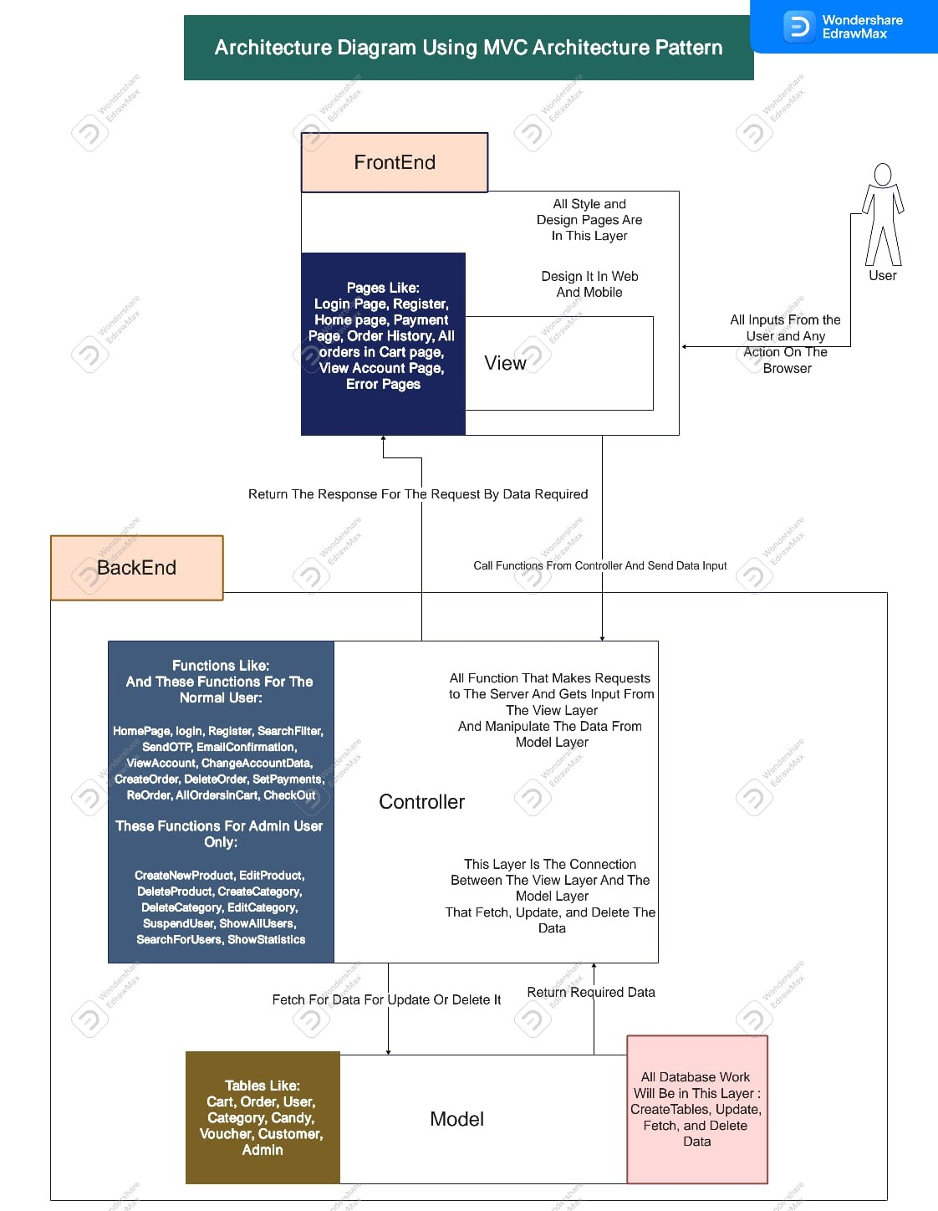

## II. Class Diagram(s)

## III. Class Descriptions

| Class ID | Class Name | Description & Responsibility |
| --- | --- | --- |
| F1 | System | This class represents the overall system that manages the store website. Its responsibilities include managing user authentication, handling requests from users, coordinating communication between different parts of the system, and ensuring that the system is running smoothly. |
| F2 | User | This class represents a user of the store website, and its responsibilities include managing user authentication and authorization, providing access to the appropriate parts of the system based on the user's role (e.g., customer, administrator), and managing user preferences and settings. |
| F3 | Administrator | This class represents an administrator of the store website, and its responsibilities include managing the store's inventory, processing orders, managing user accounts and permissions, and overseeing the overall operation of the store. |
| F4 | Customer | This class represents a customer of the store, and its responsibilities include browsing and purchasing items, managing their account and preferences, and providing feedback on their experience with the store. |
| F5 | Order | This class represents an order placed by a customer, and its responsibilities include managing the details of the order (e.g., items purchased, shipping information, payment details), processing the order, and providing updates to the customer on the status of their order. |
| F6 | ShippingInfo | This class represents the shipping information associated with an order, and its responsibilities include managing the details of the shipping address, tracking shipping status, and handling any issues related to shipping. |
| F7 | Item | This class represents an item that can be purchased from the store, and its responsibilities include managing the details of the item (e.g., name, description, price), tracking inventory levels, and handling any issues related to the item (e.g., returns or exchanges). |
| F8 | Category | This class represents the categories of items available in the store, and its responsibilities include managing the categories and organizing items into the appropriate categories. |
| F9 | Supplier | This class represents the suppliers of the items available in the store, and its responsibilities include managing supplier information and relationships, tracking supplier performance, and handling any issues related to supplier management. |
| F10 | Brand | This class represents the brands of the items available in the store, and its responsibilities include managing brand information and relationships, tracking brand performance, and handling any issues related to brand management. |
| F11 | Payment(interface) | This interface represents the basic properties and methods required for any type of payment, such as the amount and payment date, and the ability to process and validate the payment. |
| F12 | PayPalPayment | This class represents a payment made using PayPal, and its responsibilities include implementing the `Payment` interface methods in a way that is specific to PayPal, such as handling PayPal authentication and authorization, processing PayPal payments, and handling any issues related to PayPal payments. |
| F13 | CashOnDeliveryPayment | This class represents a payment made using cash on delivery, and its responsibilities include implementing the `Payment` interface methods in a way that is specific to cash on delivery, such as managing the details of the cash payment, processing the payment, and handling any issues related to cash payments. |
| F14 | CreditCardPayment | This class represents a payment made using a credit card, and its responsibilities include implementing the `Payment` interface methods in a way that is specific to credit card payments, such as managing credit card information, processing credit card payments, and handling any issues related to credit card payments. |

## IV. Sequence diagrams

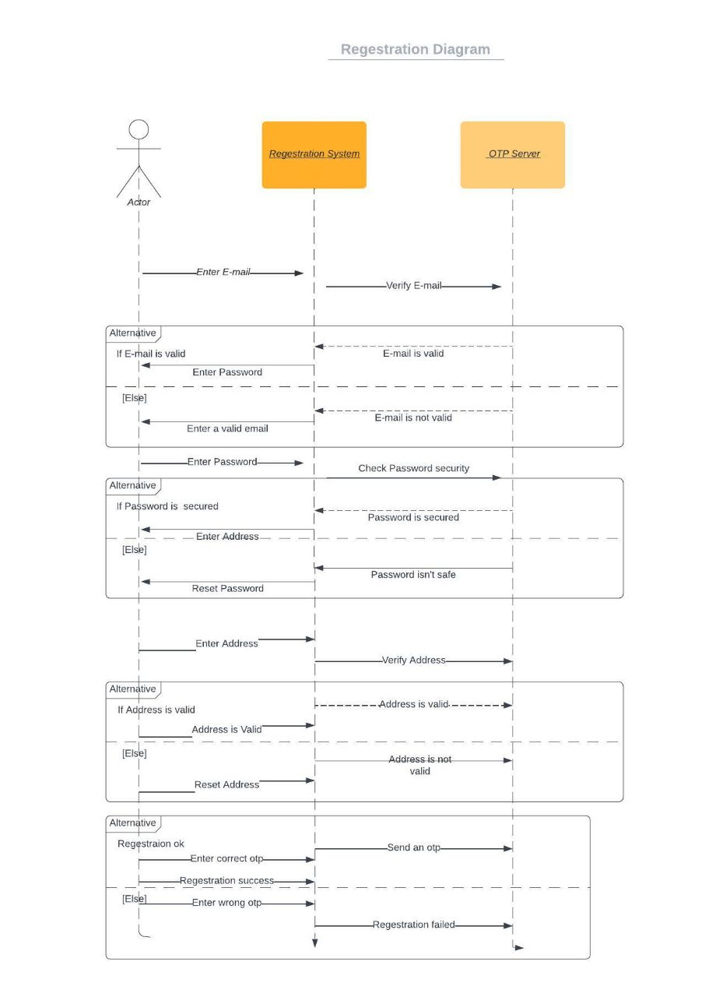

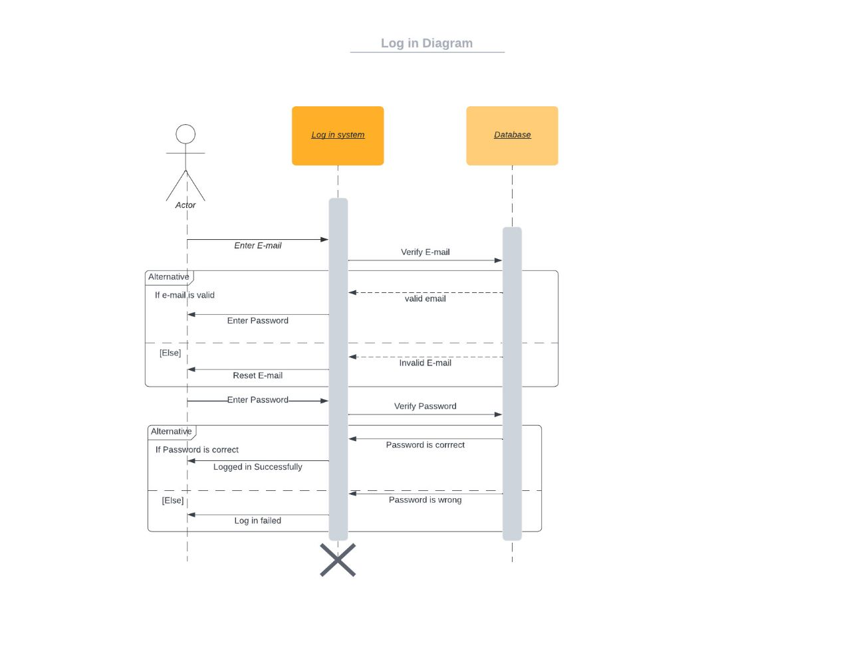

### 

### 

*P*

*a*

*y*

*m*

*e*

*n*

*t*

### 

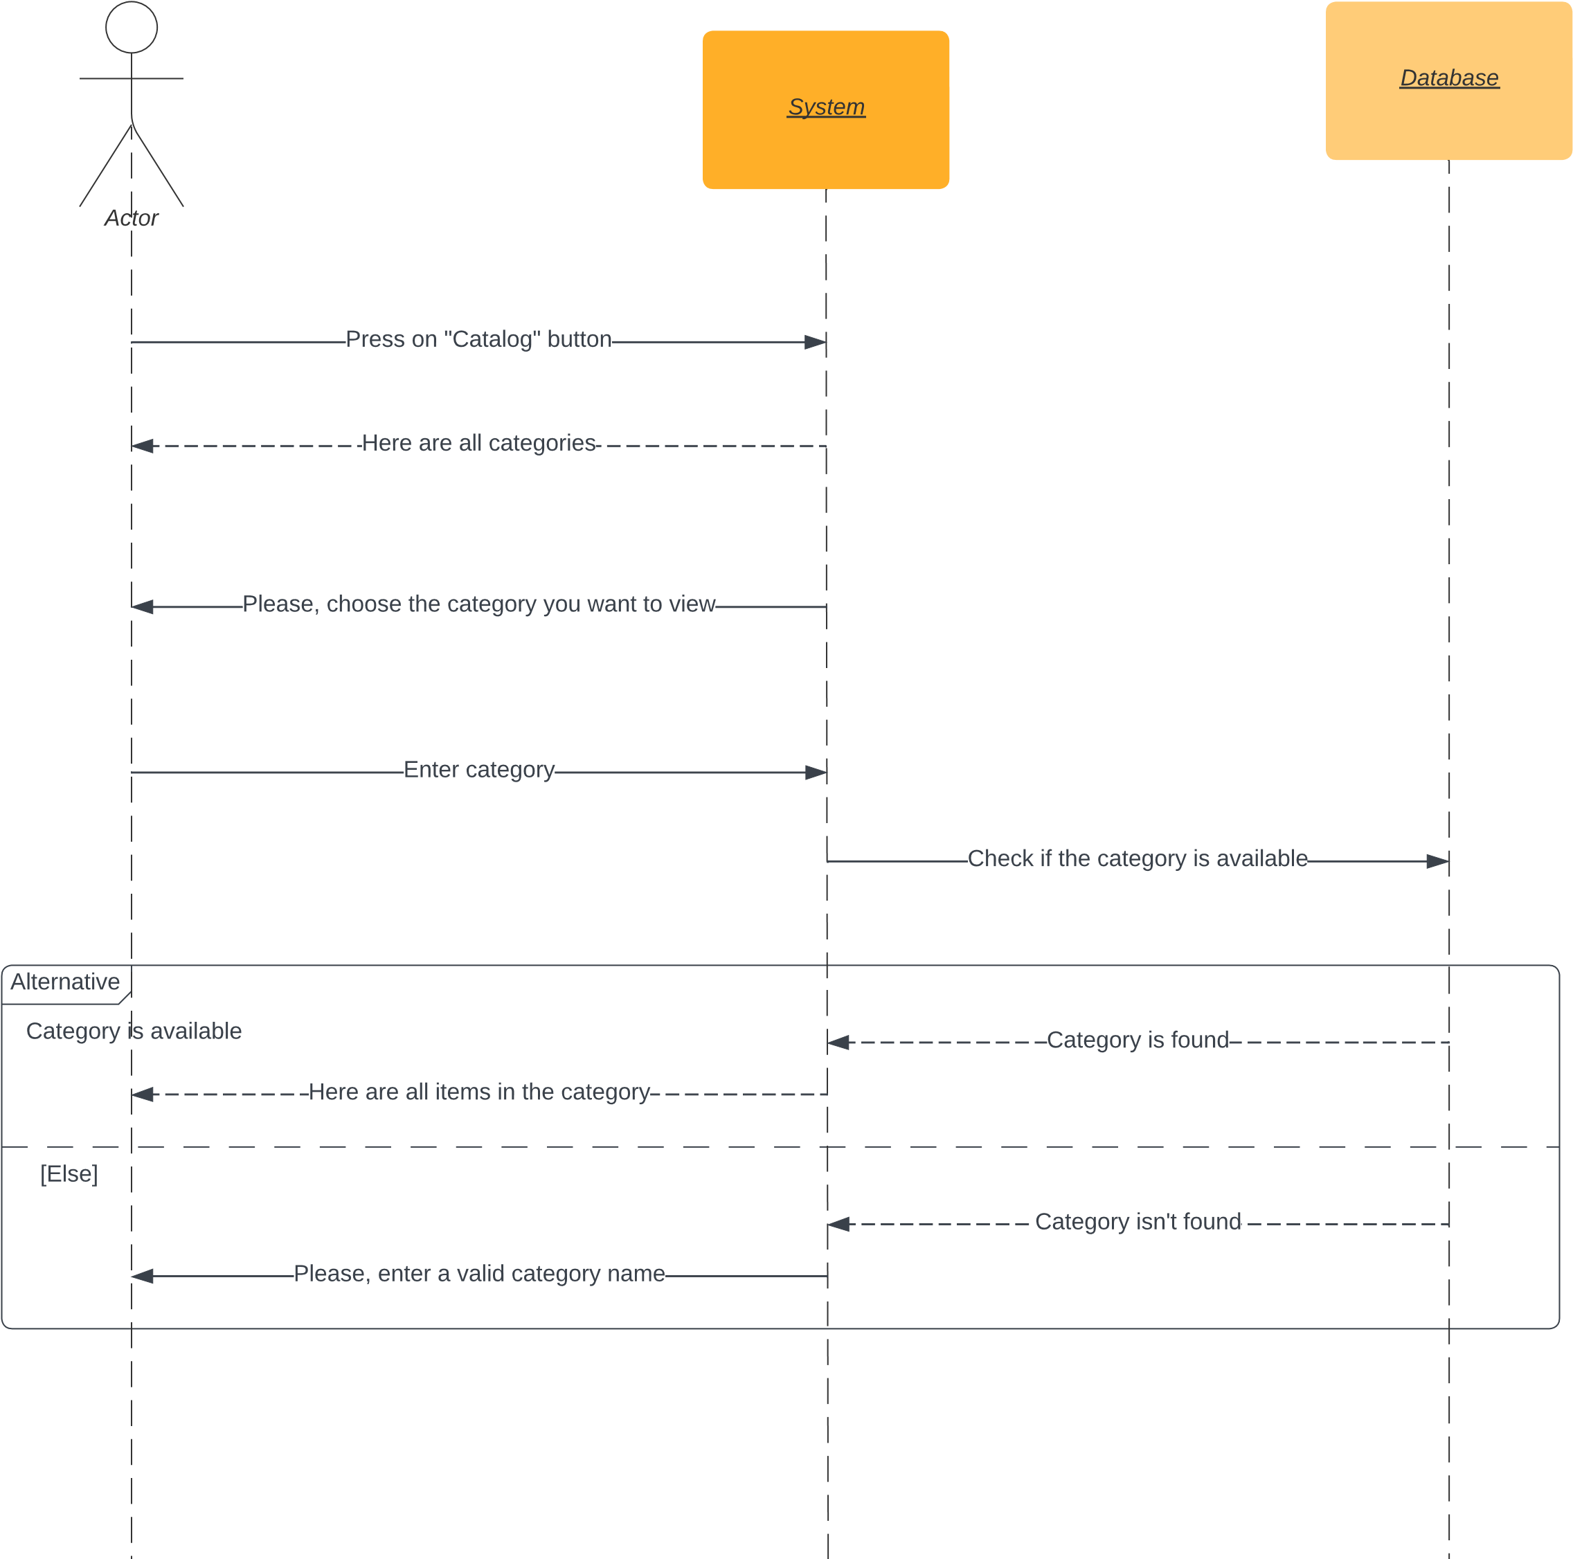

*V*

*i*

*e*

*w*

*i*

*t*

*e*

*m*

*s*

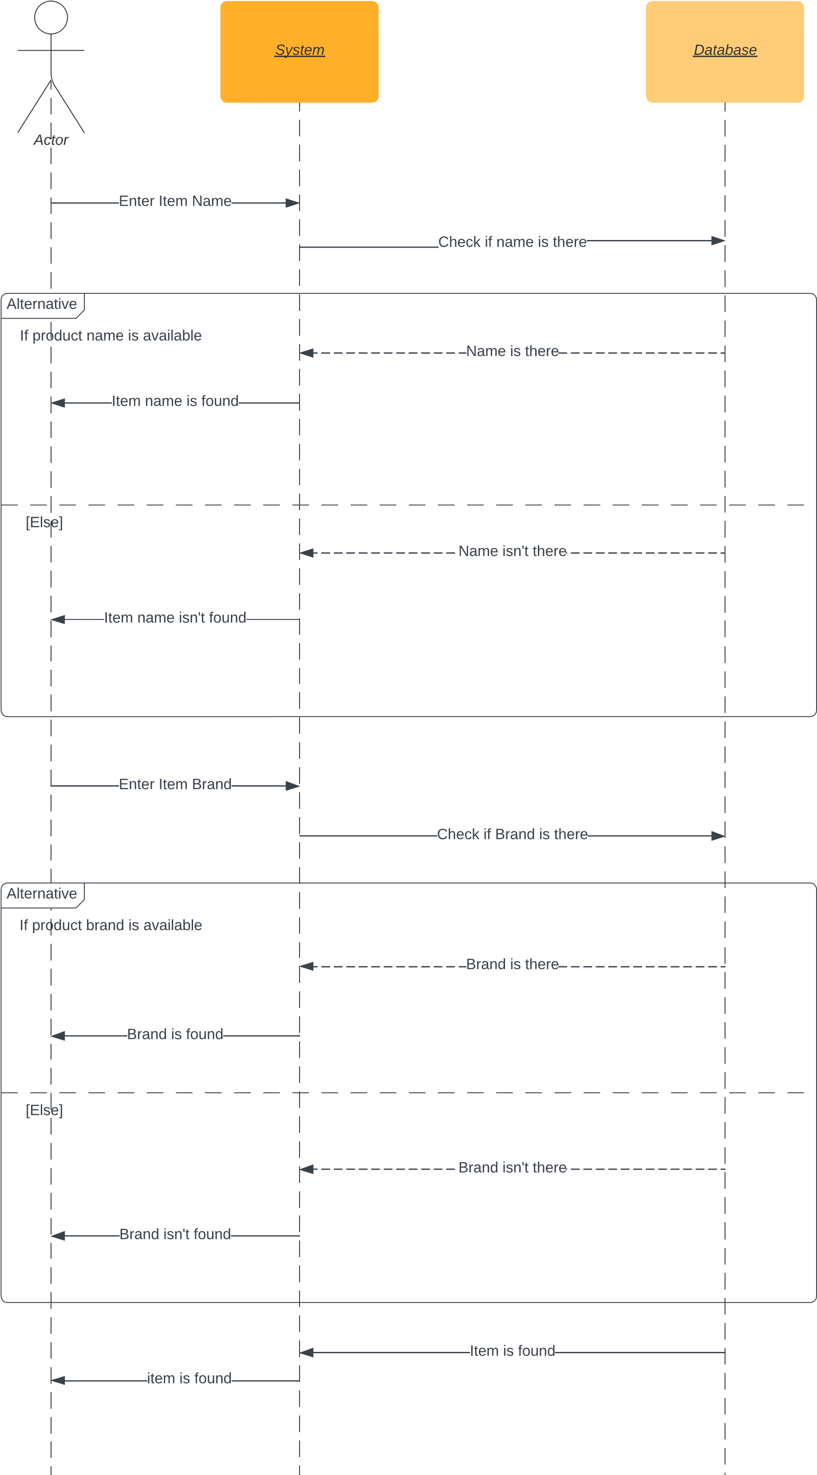

### Class - Sequence Usage Table

|  |  |  |
| --- | --- | --- |
| Sequence Diagram | Classes used | All methods used |
| 1- Registration field | 1-Class system  2-Class customer | +register(cust:customer):bool +addcustomerinfo(name:string,id:int, email:string,phone:string) |
| 2- Log in field | 1. Class system 2. Class user | +login(cus:customer):bool  +verifyLogin():bool |
| 3- Search field | 1- Class category | +searchitem(itName:string):item[]  +searchitembra(itbra:brand):item[] |
| 4- View items field | 1. Class system 2. Class customer | +viewallitems():void  +viewitems():void |
| 5- Placing an order field | 1- Class order | +searchitem(nameIt:string)  +removeitem(it:item):void  +cancelorder():void |
| 6- Payment field | 1. Class payment 2. Class creditCardpayment   3-Class  PayPalpayment | +paymentProcess  +getCardNumber():string  +getaccountEmail():string |

## V. State Diagram

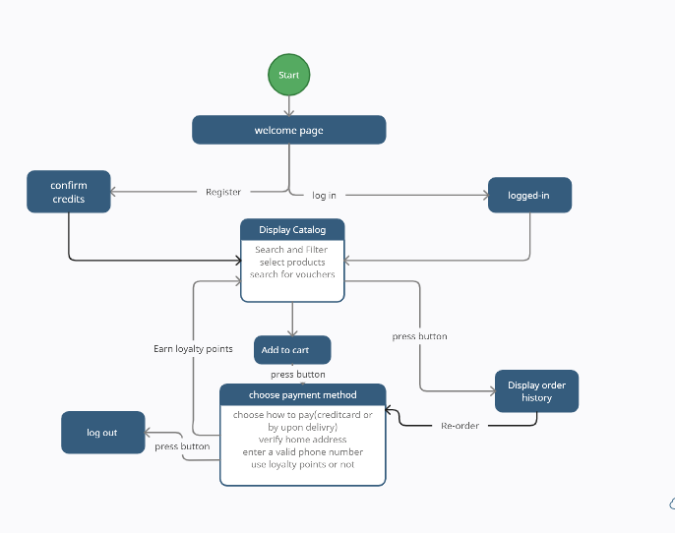

# Tools

* LucidChart

# Ownership Report

|  |  |
| --- | --- |
| **Item** | **Owners** |
| **Eslam Mohamed Abdelazim Ali Tolba** | **Class diagrams, class descriptions** |
| Mohamed Elsayed Mohamed Abd-Elmoty | **Sequence diagram, class-sequence-usage table** |
| Mostafa Abdelwahab abbas | **Architecture diagram, state diagram** |